Software Requirements Specification

QURAN WORLD



**Authors**

*Jawad khan (FA17-BSE-078)*

*Saad Naseer (FA17-BSE-014)*

**Affiliation**

*COMSATS University Islamabad, Wah Campus*

8-Jan-2021

Contents

1.Introduction 3

1.1 System introduction 3

1.2 Background of system 3

1.3 Objective of system 4

1.4 Significance of system 4

2. Overall description 4

2.1 Product perspective 4

2.2 Product scope 5

2.3 Product functionalities 5

2.4 Users and characters 5

2.5 Operating environment 6

3. Specific requirements 6

3.1 functional requirements 6

3.2 Behavior requirements 7

3.3 External interface requirements 8

3.3.1 User interface 8

4. Other Non-functional Requirements 11

4.1 Performance requirements 11

4.2 Safety and Security Requirements 11

4.3 Software quality attributes 12

4.3.1 Correctness 12

4.3.2 Maintainability: 12

4.3.3 interoperability: 12

5. Design Description 13

5.1 Composite viewpoint 13

5.2 Logical viewpoint 14

5.3 Information viewpoint 15

5.4 Interaction viewpoint 16

5.5 State dynamic viewpoint 17

5.6 Algorithm viewpoint 18

# 1.Introduction

## System introduction

Quran world is a machine leering web-based project in which user will enter any word or phrase in three languages (English, Urdu, Arabic). The system will retrieve all Ayat e Karima with their Urdu and English translation, hadith shareef related to input token. The reference of Ayat such as para no, Surat name Ayat number of sura, hadith number, source of hadith and reference book of hadith are provided to user. In order to implement this project, we will use vector space model, synonyms and keyword-based search as a baseline to retrieve relevant record

## Background of system

Most of the search engine developed using vector space model only uses tf idf to extract the result the structure of previous systems is below

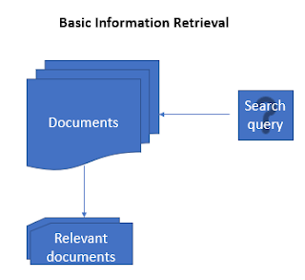

but in our project we have implemented tfidf , cosine similarity, synonyms to extract better results. The overall structure of our search engine is given below

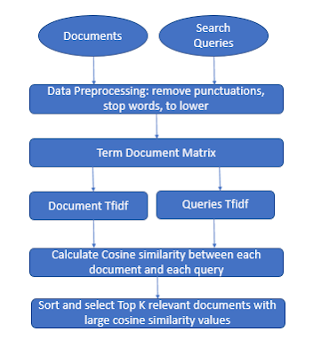

## Objective of system

* User will enter any keyword, phrase. User can search Ayat Kareem from Quran e Pak on the bases of entered token
* System will retrieve Hadith shareef on the bases of entered token or phrase
* User can see prayers timing of different cities of Pakistan
* User can learn different Duas
* User can learn Namaz with Urdu translation

## Significance of system

Since the main purpose of the system is to search and retrieve data based on the query. So by changing only the dataset we can implant this system. Search engines essentially act as filters for the wealth of information available in a specific dataset or not. They allow users to quickly and easily find information that is of genuine interest or value.

Let’s suppose if you want to implement a simple search engine on a book, novel or on any data set you can use this project. You have to just change the dataset and hence it will reduce cost that is required in development of a new system.

# 2. Overall description

## 2.1 Product perspective

The overall architecture of the system is given below. The user will interact with templet (ui) and put his quires there. Then the templet will send that request to view and view will be able to forward query to model. Model is connected with search engine. The results will be sanded to model. Model will pass the results to view and view render the results to user interface

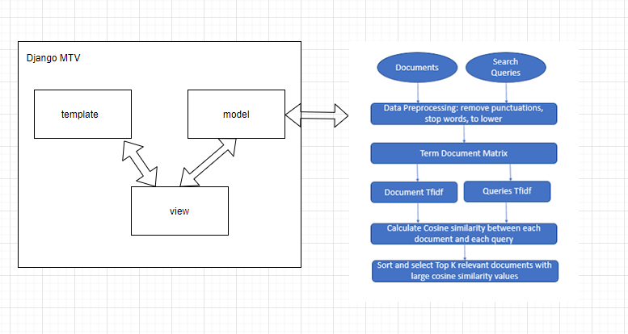

## 2.2 Product scope

Quran world is a machine leering web-based project in which user will enter any word or phrase in three languages (English, Urdu, Arabic). The system will retrieve all Ayat e karima with their Urdu and English translation, hadith shareef related to input token and tafsir of Ayat e karima. The reference of Ayat such as para no, Surat name Ayat number of sura, hadith number, source of hadith and reference book of hadith are provided to user.

In order to implement this project, we will use vector space model, synonyms and keyword-based search as a baseline to retrieve relevant record

## 2.3 Product functionalities

* User will enter any keyword, phrase. User can search Ayat Kareem from Quran e Pak on the bases of entered token
* System will retrieve Hadith shareef on the bases of entered token or phrase
* User can see prayers timing of different cities of Pakistan
* User can learn different Duas
* User can learn Namaz with Urdu translation

## 2.4 Users and characters

**Users:**

User

**Characteristics:**

* User will enter any keyword, phrase. User can search Ayat Kareem from Quran e Pak on the bases of entered token
* System will retrieve Hadith shareef on the bases of entered token or phrase
* User can see prayers timing of different cities of Pakistan
* User can learn different Duas
* User can learn Namaz with Urdu translation

## 2.5 Operating environment

The software will operate with the following software components and applications: The software being developed will be running under windows operating system. The hardware that will be running these programs will be, 2gb ram, 5gb free space in hard disk The synchronization procedures will be written to interface with Windows 7

# 3. Specific requirements

## 3.1 functional requirements

This section lists the functional requirements in ranked order from more important to least important.

|  |  |  |  |
| --- | --- | --- | --- |
| **S. No.** | **Functional Requirement** | **Type** | **Status** |
| 1 | The user should be able to search from  Quran | Core | Completed |
| 2 | The user should be able to search from  Hadith | Core | Completed |
| 3 | The user should be able to learn duas from  Quran. | Core | Uncompleted |
| 4 | The user should be able see prayers timing of different cities | Core | Completed |
| 5 | The user should be able to search from  Hadith using voice search | Core | Uncompleted |
| 6 | The user should be able to search from  Quran using voice search | Core | Uncompleted |
| 7 | The user should be able to search from  Quran by putting query in English, Urdu and  Arabic language | Core | Uncompleted |
| 8 | The user should be able to search from  Hadith by putting query in English, Urdu and Arabic language | Core | Uncompleted |

## 3.2 Behavior requirements

**Actors:**

User

**Use cases:**

1. Search from Quran

User will enter any keyword, phrase. User can search Ayat Kareem from Quran e Pak on the bases of entered token. System will retrieve Ayats on the bases of entered token or phrase. User can search query either by text or voice search option

1. Search from Hadith

User will enter any keyword, phrase. User can search Hadith from Bukhari shreef on the bases of entered token. System will retrieve Hadith on the bases of entered token or phrase. User can search query either by text or voice search option

1. Check prayer times

User can see prayers timing of different cities of Pakistan

1. Learn Duas

User can learn different Duas

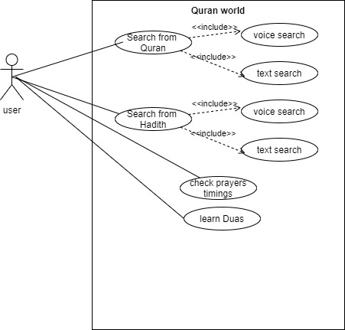

## 3.3 External interface requirements

## 3.3.1 User interface

Home page

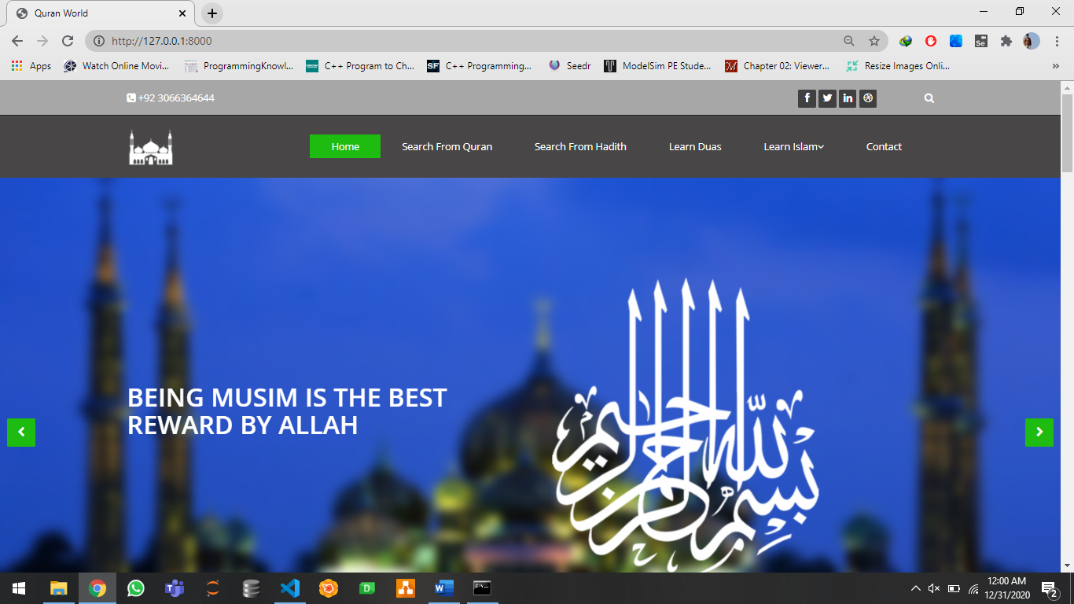

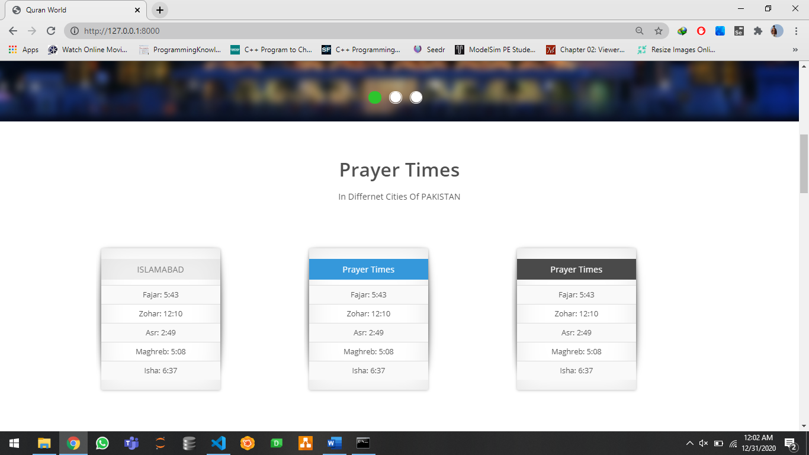

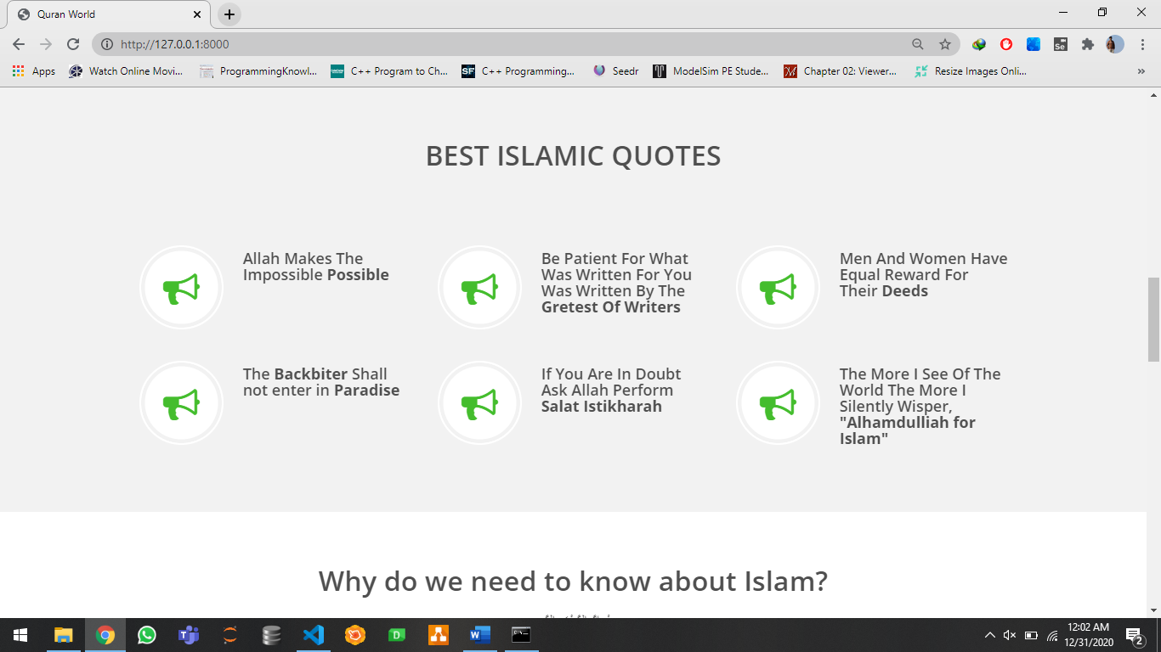

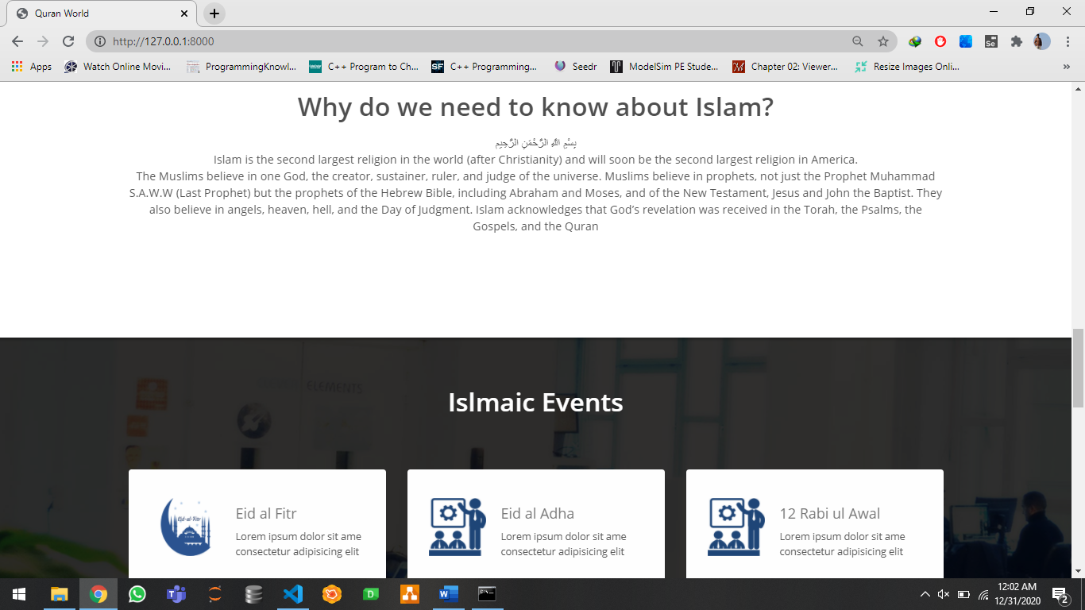

Search from QURAN page

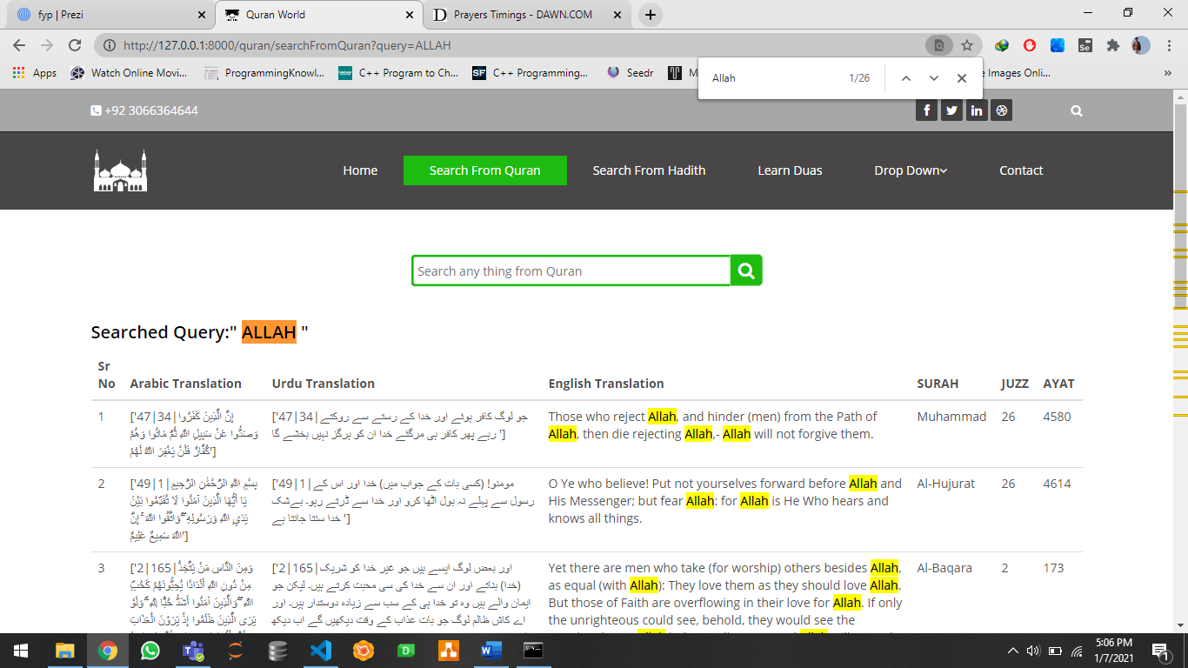

Search from Hadith page

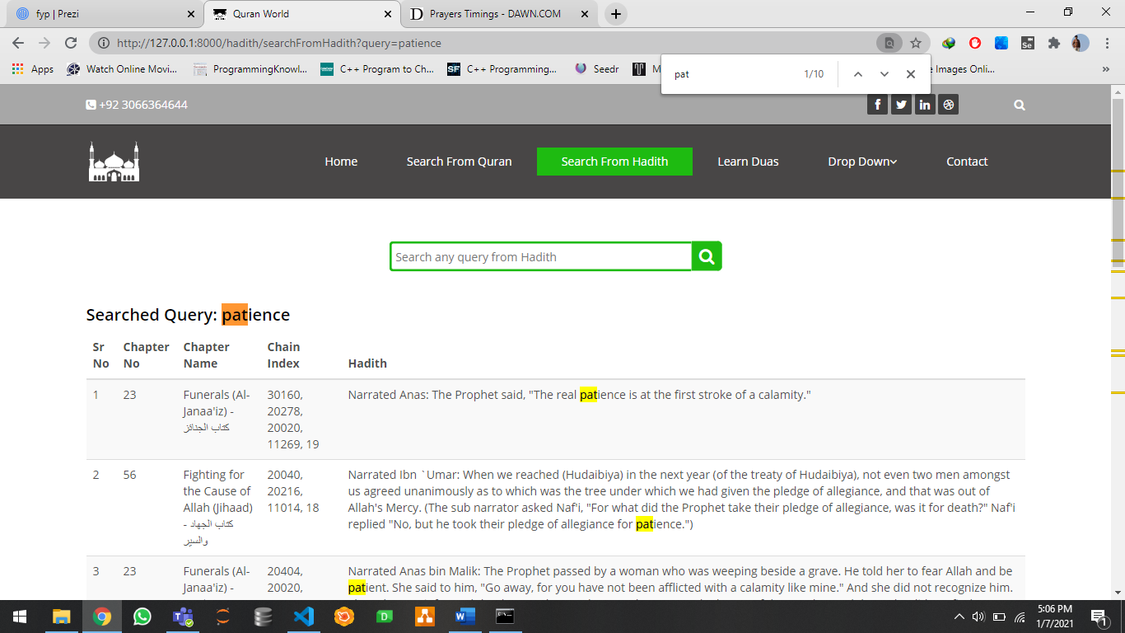

Contact us page

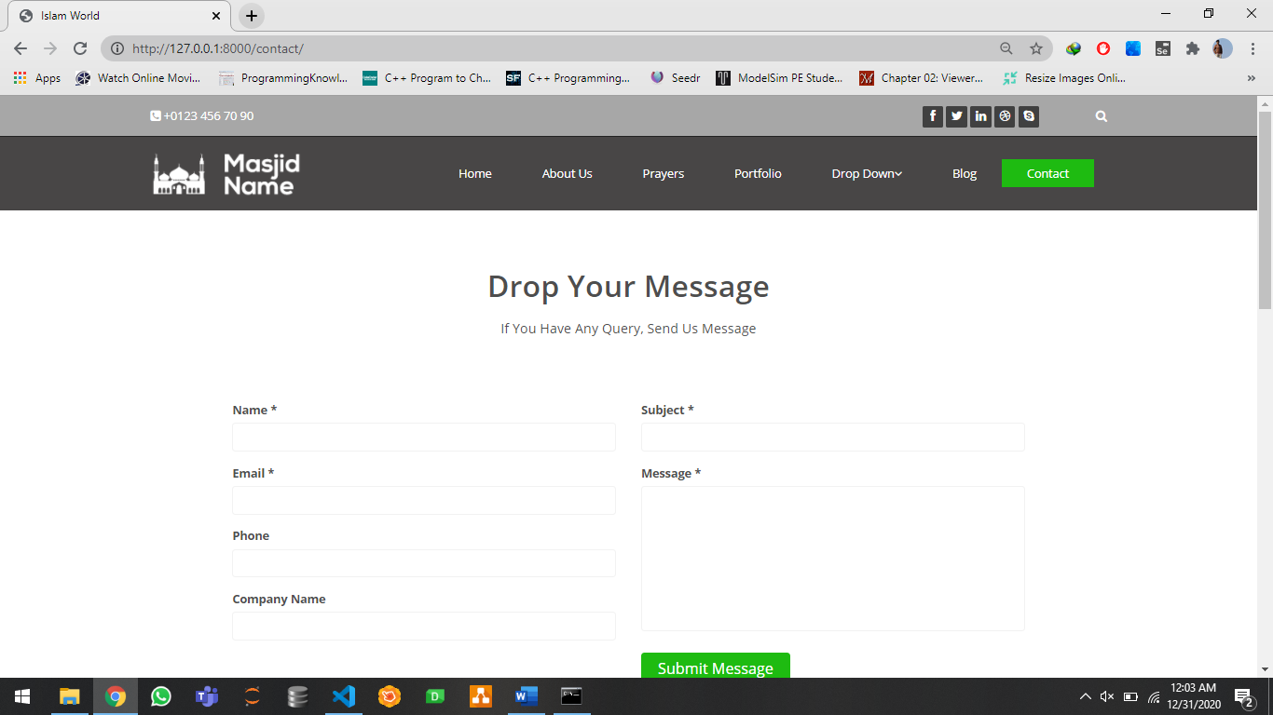

# 4. Other Non-functional Requirements

## 4.1 Performance requirements

1. search results should be displayed <1 second

2. the delay should be < 0.5 seconds

3. when the player moves in either direction the response should be < 0.2 s

4. prayer timings must be scrapped < 0.1 s

## 4.2 Safety and Security Requirements

**Availability:**

the server should be available (security level: high)

**Testability:**

all the functional requirements are testable in the end (security level: high)

**Unambiguous product:**

the system should be understandable by other users (security level: medium)

**Consistency:**

we are approaching each requirement in the same way to ensure that the security measures are applied consistently across the board

## 4.3 Software quality attributes

## 4.3.1 Correctness

The system is designed according to the requirements.

## 4.3.2 **Maintainability:**

The system is maintainable, we can implement new requirements in system. We can maintain the existing system.

## 4.3.3 interoperability:

All the modules work independent. But all the modules are able to exchange different information with each other so our system is interoperable

# 5. Design Description

## 5.1 Composite viewpoint

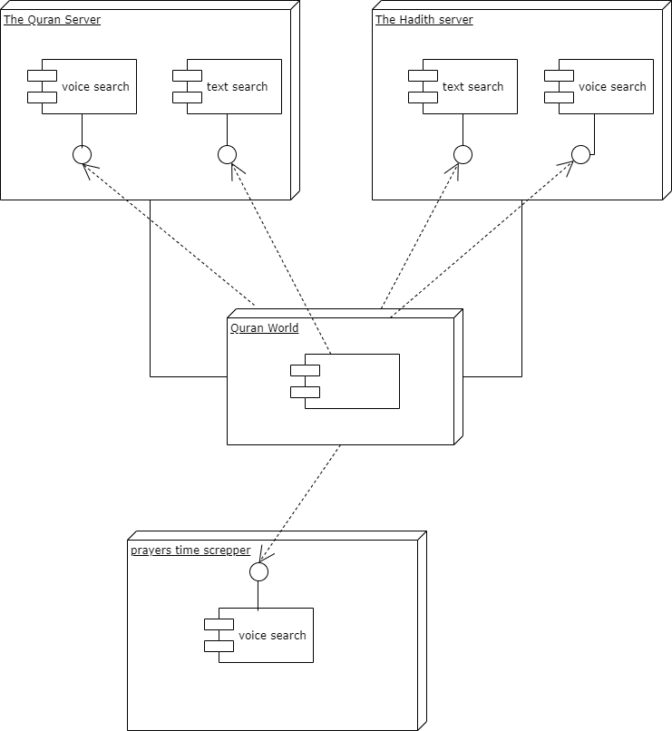

## 5.2 Logical viewpoint

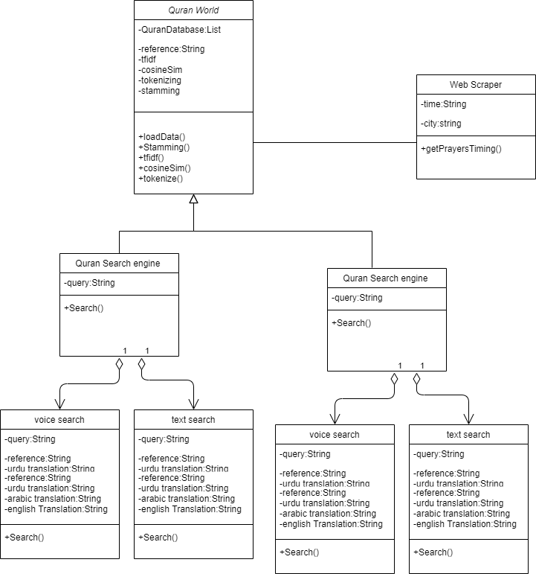

## 5.3 Information viewpoint

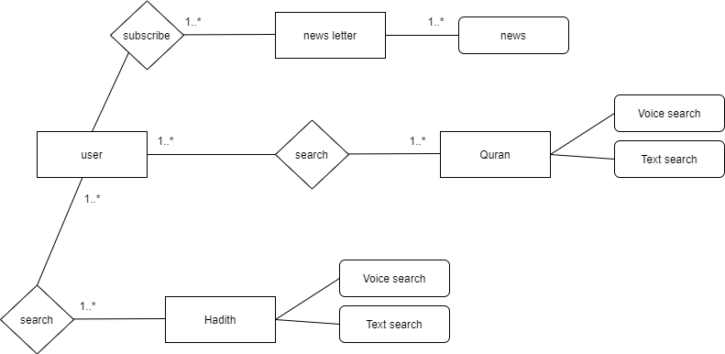

## 5.4 Interaction viewpoint

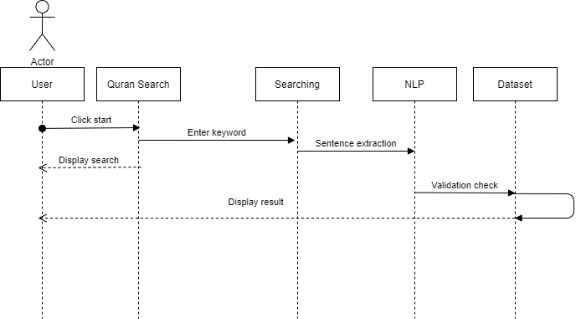

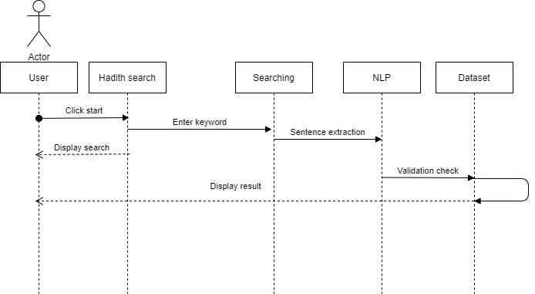

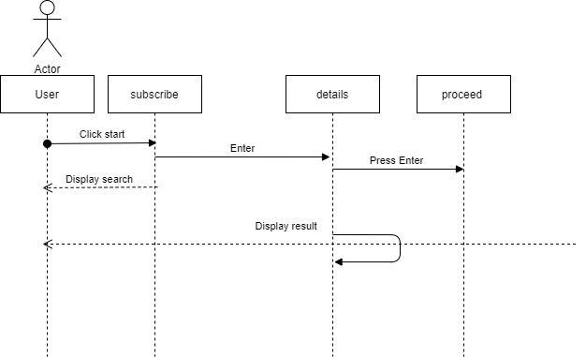

## 5.5 State dynamic viewpoint

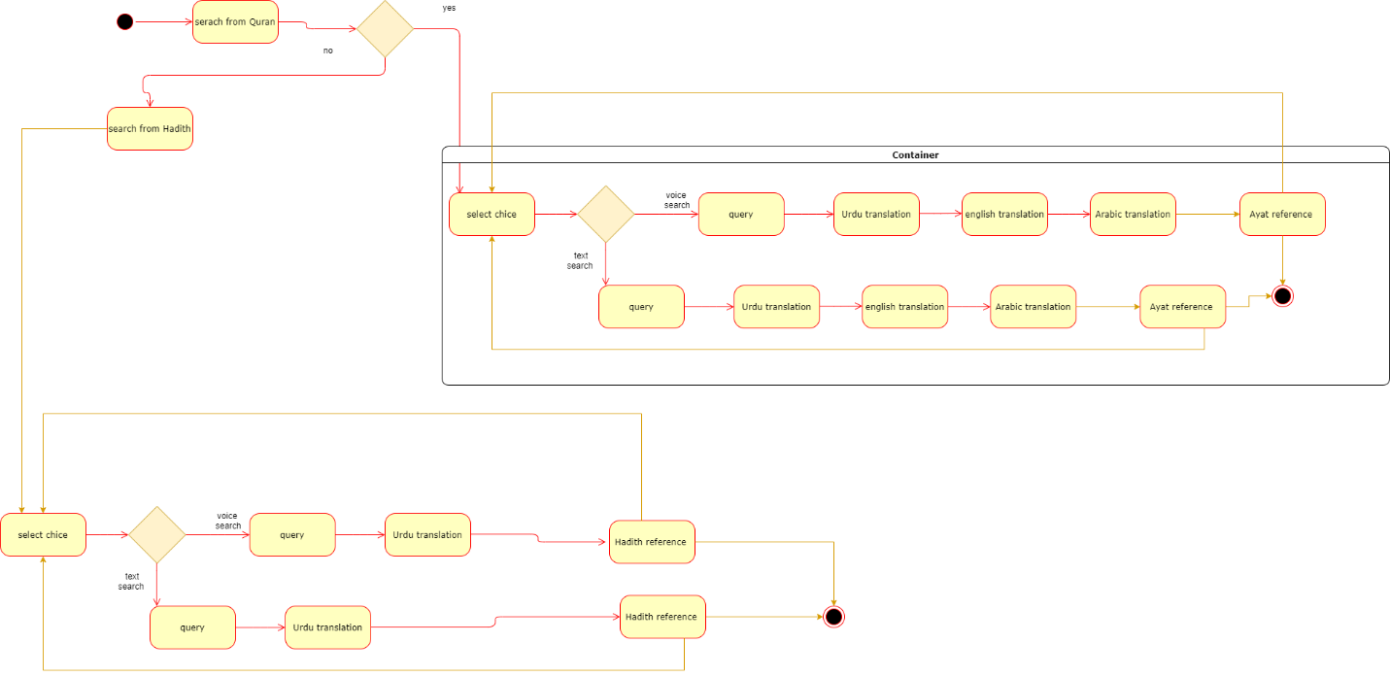

## 5.6 Algorithm viewpoint

